The Report of 5th Programming Homework

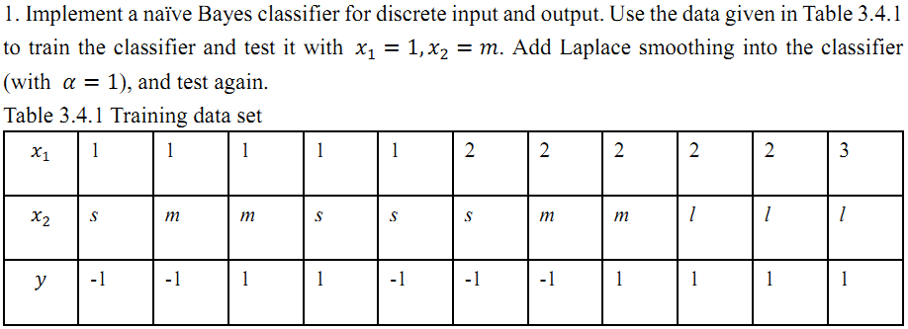

In this experiment, the key point is to write functions that can calculate the empirical distributions with or without Laplace smoothing. In “Generative_Bayesian.m”, I defined “naive_distribution” to calculate the empirical distributions and use a parameter to determine whether to use Laplace smoothing. And then calculate the output. The step are as follow:

1. input the training dataset
2. Find the variables in $x_{1}$, $x_{2}$, $y$
3. Calculate $p(y)$, $p(y|x_{1})$, , $p(y|x_{2})$, (whether to use Laplace smooth is determined by the parameter ‘is_)smooth’)
4. Calculate $p(y|x_{1}=1,x_{2}=m)$ and return the max y as output.

In this experiment, the output is y = -1 with or without using Laplace smoothing.

|  |  |  |
| --- | --- | --- |
|  | Without Laplace smoothing | With Laplace smoothing |
|  | 0.0606 | 0.0606 |
|  | 0.1091 | 0.0852 |